**Proj 4: Science Biomimicry**

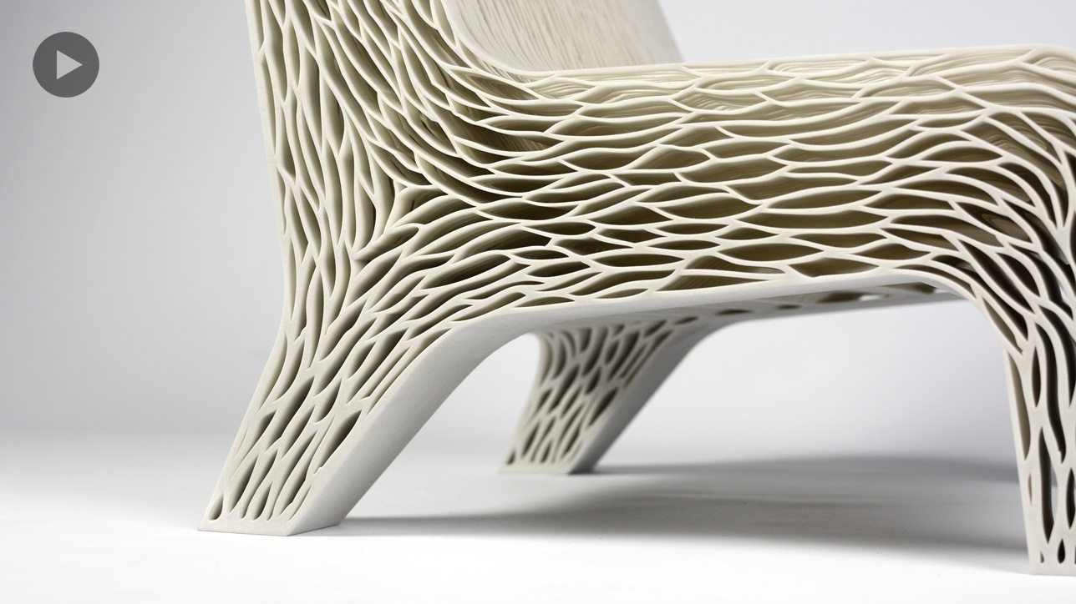

**Objective:** Design a device that features key literary components from books of literature.

**Need:** To create an interactive and unique way to reinforce literary concepts for teachers to use in their classrooms.

**Agenda:**

Day 1 (T. 11/10) Phase 1 (Discovery): Guest Presenter to discuss biomimicry.

Day 2 (W. 11/11) Phase 2 (Interpretation): Research your topic. Decide which theme(s) you would use, key concepts and key components.

Day 3 (Th. 11/12) Phase 3 (Ideation): Continue research and start brainstorming ways to accomplish challenge. Create as many sketches as possible of inspiration from nature and design layouts in sketchbook.

Day 4 (F. 11/13) Phase 2 (Ideation): Field Trip

Day 5 (M. 11/16) Phase 4 (Experimentation): Finalize idea and start prototype.

Day 6 (T. 11/17) Phase 4 (Experimentation): Continue working on your prototype.

Day 7 (W. 11/18) Phase 4 (Experimentation): Continue working on your prototype.

Day 8 (Th. 11/19) Phase 4 (Experimentation): Continue working on your prototype. Print 3D or paper design.

Day 9 (F. 11/20) Phase 4 (Experimentation): Continue working on your prototype. Print 3D or paper design.

Day 10 (M 11/23) Phase 4 (Experimentation): Continue working on your prototype. Print 3D or paper design.

Day 10 (T. 11/24) Phase 4 (Experimentation): Last work day.

**Directions:**

1. Get into new design team. Decide on a physical disability.
2. Research what it would be like to have that disability (pros and cons). Collect data about it and the people who have it.
3. Create an assistive device that mimics nature and helps the “client” with their physical disability.
4. Create a Design Board (will need for pitching idea). Will need:
   1. Have either a sketch of the design (print paper copy from Tinkercad) or 3-D printed prototype.
   2. Label: title, information about the disability and any additional information needed.
   3. Infographic: All data collected in research of disability must be visually displayed in an interesting way. Log onto Piktochart.com to create your infographic.
5. Get ready to pitch your idea.

**Resources:**

* <http://www.disabled-world.com/disability/statistics/census-stats.php>
* John Hopkins: <http://web.jhu.edu/disabilities/faculty/types_of_disabilities/>
* <http://www.cyh.com/HealthTopics/HealthTopicDetails.aspx?p=114&np=306&id=1874>
* CDC: <http://www.cdc.gov/ncbddd/disabilityandhealth/types.html>
* Infographic: <http://piktochart.com/piktochart-infographics/>

**Rubric: 50 pts total (5 pts each)**

1. FORM: Is the design (style) aesthetically pleasing? Is the design interesting from all directions? Were all sides considered for the design? Is it proportionate and to scale?
2. FIT: Does the parts all go together?
3. FUNCTION: What is the function of your design? Use space below to describe how your prototype will work.
4. PROTOTYPE: Was one created (drawn or printed)? Print: Were all sides considered in the design to create a 3-Dimensional design? Is it proportionate and to scale? Paper: Design created with care, labeled neatly, securely attached, and free of any unintentional marks or tears.
5. IDEATION: Were a variety of ideas used to make the design interesting? (Turn in sketches)
6. INTERPRETATION: How have the various issues associated with a specific disability been addressed and researched?
7. BIOMIMICRY: Was the inspiration based on nature? Is the inspiration clearly evident in the design?
8. NEED: How well does the design solve the issue of the client's need?
9. PITCH: Did the presentation have the flow of being rehearsed? Did all members or presentation have a role in the pitch?

10. INFOGRAPHICS: Was the data collected represented in a strong visual format? Was it neatly presented?

**Types of Physical Disabilities**

|  |  |  |
| --- | --- | --- |
| Traumatic brain injury (TBI) | TBI refers to any injury to the head and brain. It is the leading cause of death and physical disability to children in the US. Boys are twice as likely as girls to sustain a brain or spinal cord injury. | 95 per 100,000 |
| Cerebral Palsy | A disorder of movement caused by damage to the motor-control areas of the brain, affecting muscle tone and voluntary movements. Damage occurs from injury before or after birth that leads to oxygen deprivation or head injury. | approx. 5,000 new cases per year. |
| Spinal-cord injury | An acquired neurological disorder in which the spinal cord has been damaged. | 40 per 1,000,000 |
| Epilepsy | A seizure disorder in which the brain cells do not work properly in one or both sides of brain, causing a range of seizures from momentary (tonic-clonic) loss of consciousness with muscle twitching to (myoclonic) abrupt jerking of muscles and sudden (atonic) loss of muscle tone and loss of consciousness. | 2.3 million |
| Neutral tube defects | Spinal Bifida (SB): a small gap or defect in the backbone and the spinal cord itself or the spinal column is exposed. Encephalocele: An opening in the brain. Anencephaly: A major malformation of the brain that causes death of the fetus or infant in most cases | SB affects approx. 1 of every 1,000 children |
| Muscular Dystrophy (MD) | A progressive disease of the musculoskeletal system (muscles and skeleton) that affects all muscles and eventually the heart and diaphragm, leading to death. | 50,000-250,0000 diagnosed annually |
| Juvenile Rheumatoid Arthritis | (JRA) Arthritis is a group of disorders that affect the joints. JRA causes stiff and swollen joints and pain. | Approx. 300,000 children |
| Cystic Fibrosis | A genetic cardiopulmonary disorder that results in severe respiratory and digestive problems. | Approx. 30,000 |
| Amputations |  |  |

Team Member Names: _______________________________________________ Hr: ______

**Physical Disability Name**: __________________________________________________________________

**Vocabulary:**

* Form (aesthetics) Fit (How it goes together) Function (purpose)
* Biomimicry: Innovation inspired by nature.
* Mimic: To copy
* Assistive Device
* Scientific Method: process used in science using systematic observation, measurement and experiment, formulation, testing and modification of hypotheses.

**List possible ways to find solution for the need.**

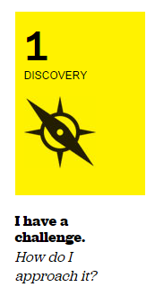

**Ask Question**

**Understand the need**

**Prepare Research Gather Inspiration**

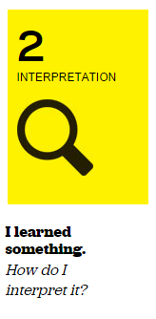

**Tell stories**

**Search for meaning**

**Frame Opportunities**

**Construct Hypothesis**

**Do Background Research**

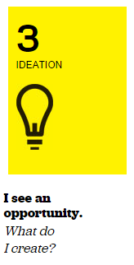

**Generate Ideas**

**Refine Ideas**

**Clarify**

**Synthesize**

**Do Background Research**

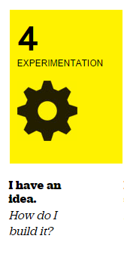

**Make Prototype**

**Get Feedback**

**Iteration**

**Analyze Results Draw Conclusions**

**Hypothesis is *True* or *False / Partially True***

**How could the design be tweaked to better fit the client’s need?**

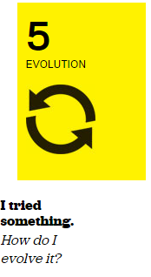

**Report Results**

**Report Results**

**Use this additional space to gather information and create sketches for ideation.**